**PRACTICAL: 1**

**AIM:**

The transmission of information needs to be secure over  the communication channel and the data has to be confidential. To do so, steganography is the technique of  concealing/hiding the secret file, message, audio, or video  in another format of the file. Study and implement the  practical approach for Steganography using the following  tools: StegSpy, OpenStego, and DeepSound.

**THEORY:**

**Steganography:** representing data in a way that a human inspection would not reveal its presence, whether it be in a message or physical object.

**Steghide:** Program that able to hide data in various kinds of images and audio files. The embedded data can be compressed, encrypted, and automatically checked for integrity using a checksum, among other features. For use as a cover file, the JPEG, BMP, WAV, and AU file formats are supported. The format of the secret data is not constrained.

Rijndael, which is an advanced encryption standard with a key size of 128 bits, is the default encryption algorithm and is used in cypher block chaining mode. You are free to select a different algorithm or mode combination if you do not trust this one for any reason (the encinfo command displays information about all potential algorithms and modes). The CRC32 algorithm is used to calculate the checksum.

**EMBEDDING COMMANDS**

-ef = Specify the file that will be embedded.

-cf = Specify the cover file that will be used to embed data.

-sf = Specify the name for the stego file that will be created.

-Z = Do not compress the secret data before embedding it.

-K = Do not embed a CRC32 checksum.

-N = Do not embed the file name of the secret file.

**EXTRACTING COMMANDS**

-sf = Specify the stego file (the file that contains embedded data).

-xf = Create a file with the name filename and write the data that is embedded in the stego file to it.

**OUTPUT:**

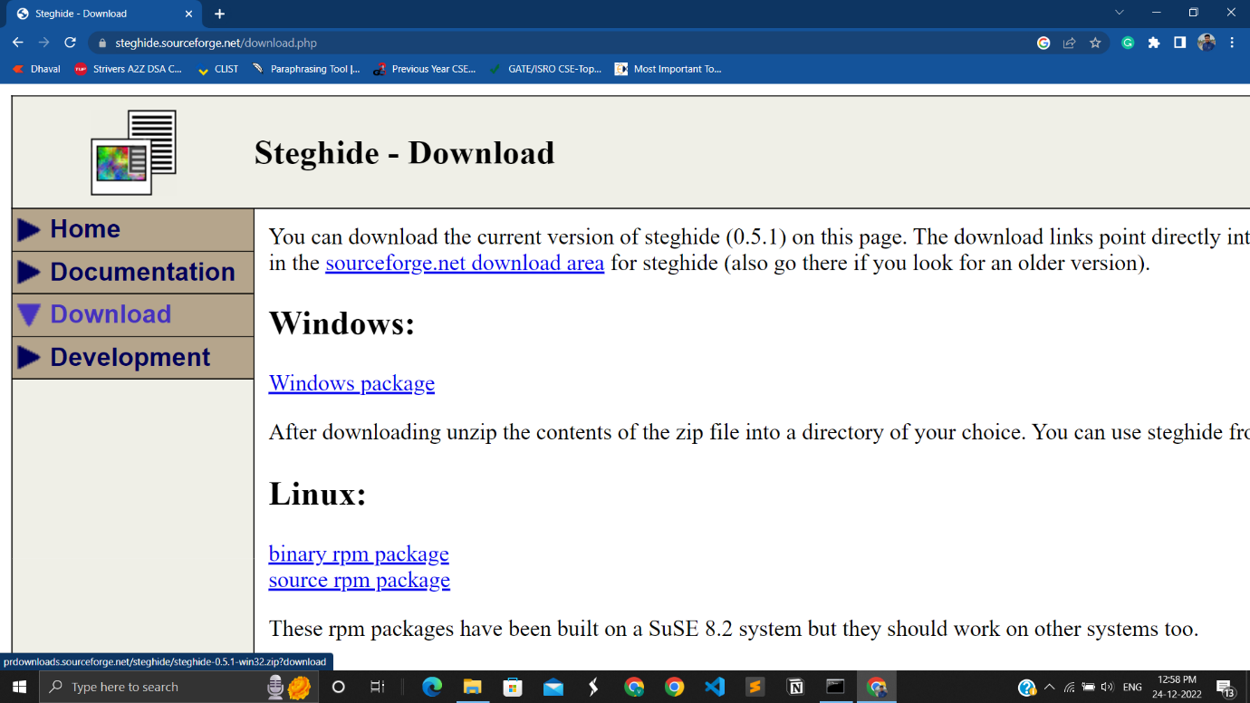

1.1 Download steghide from its official website

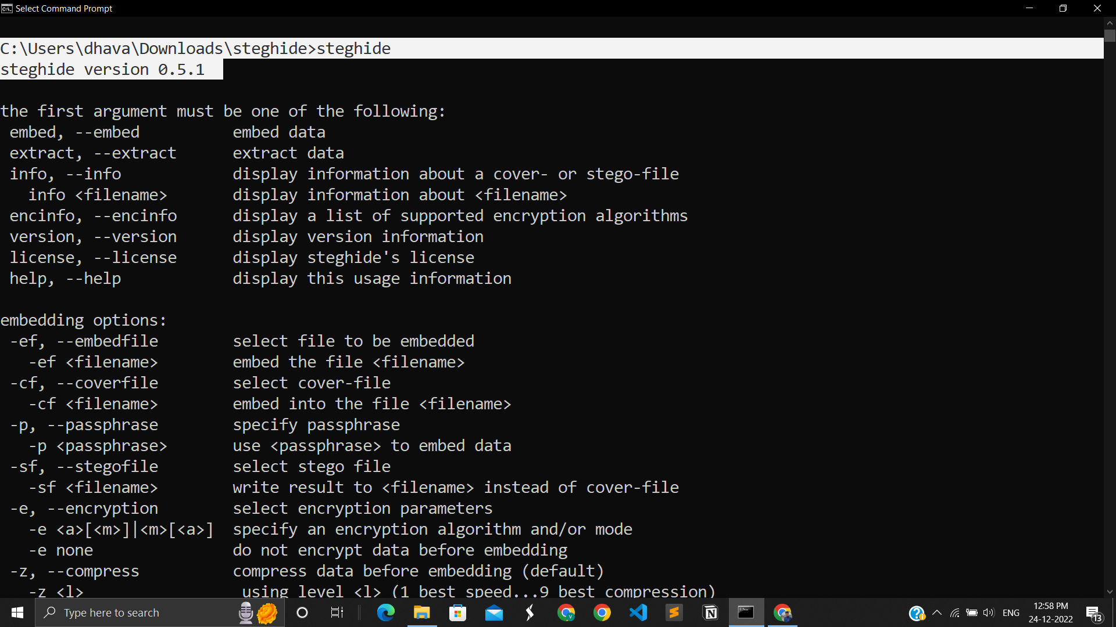

1.2 After downloading its perfectly working

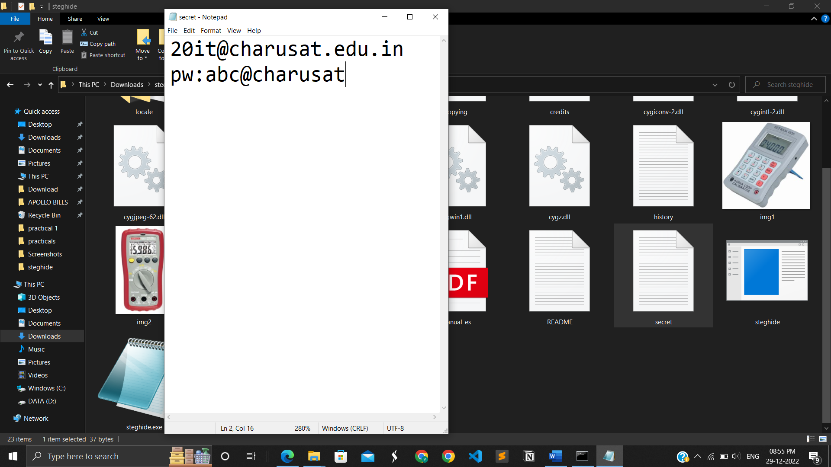

1.3 Make a .txt file in which I have written some secret data

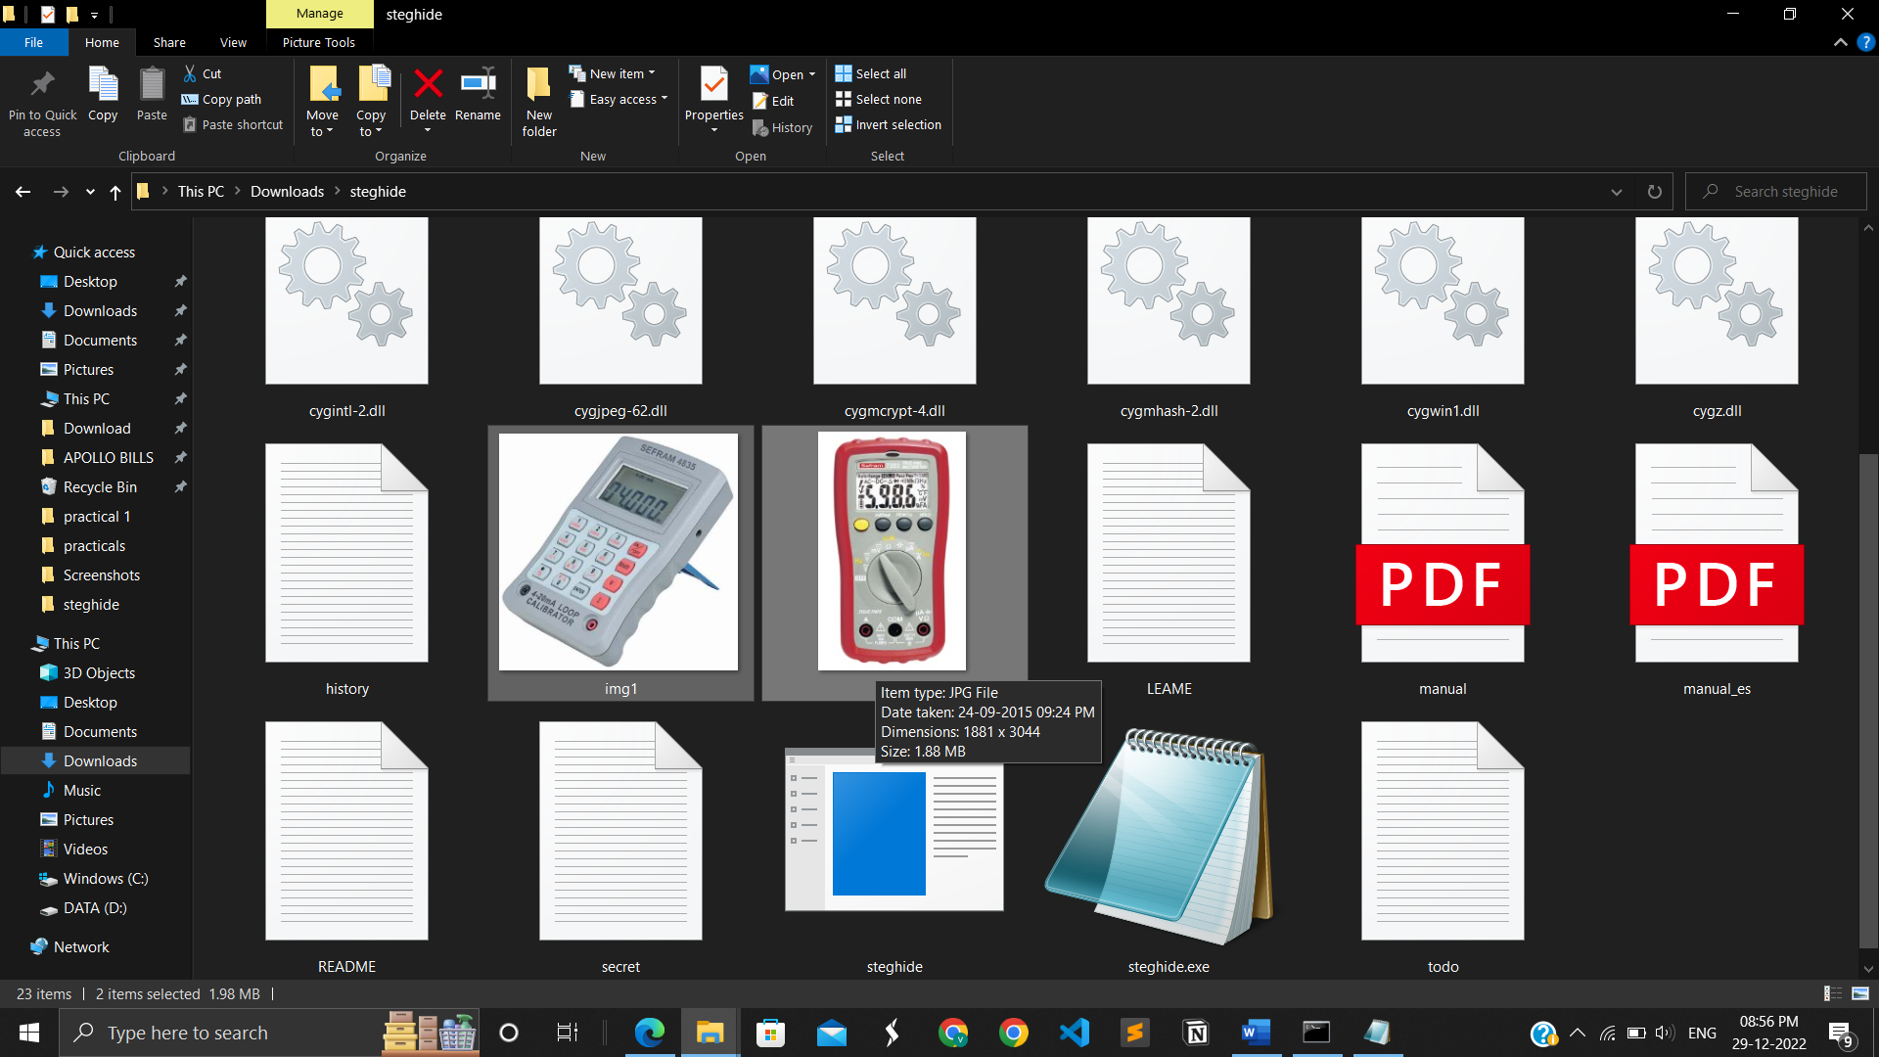

1.4 After that I have take 2 images in which I will hide my file data

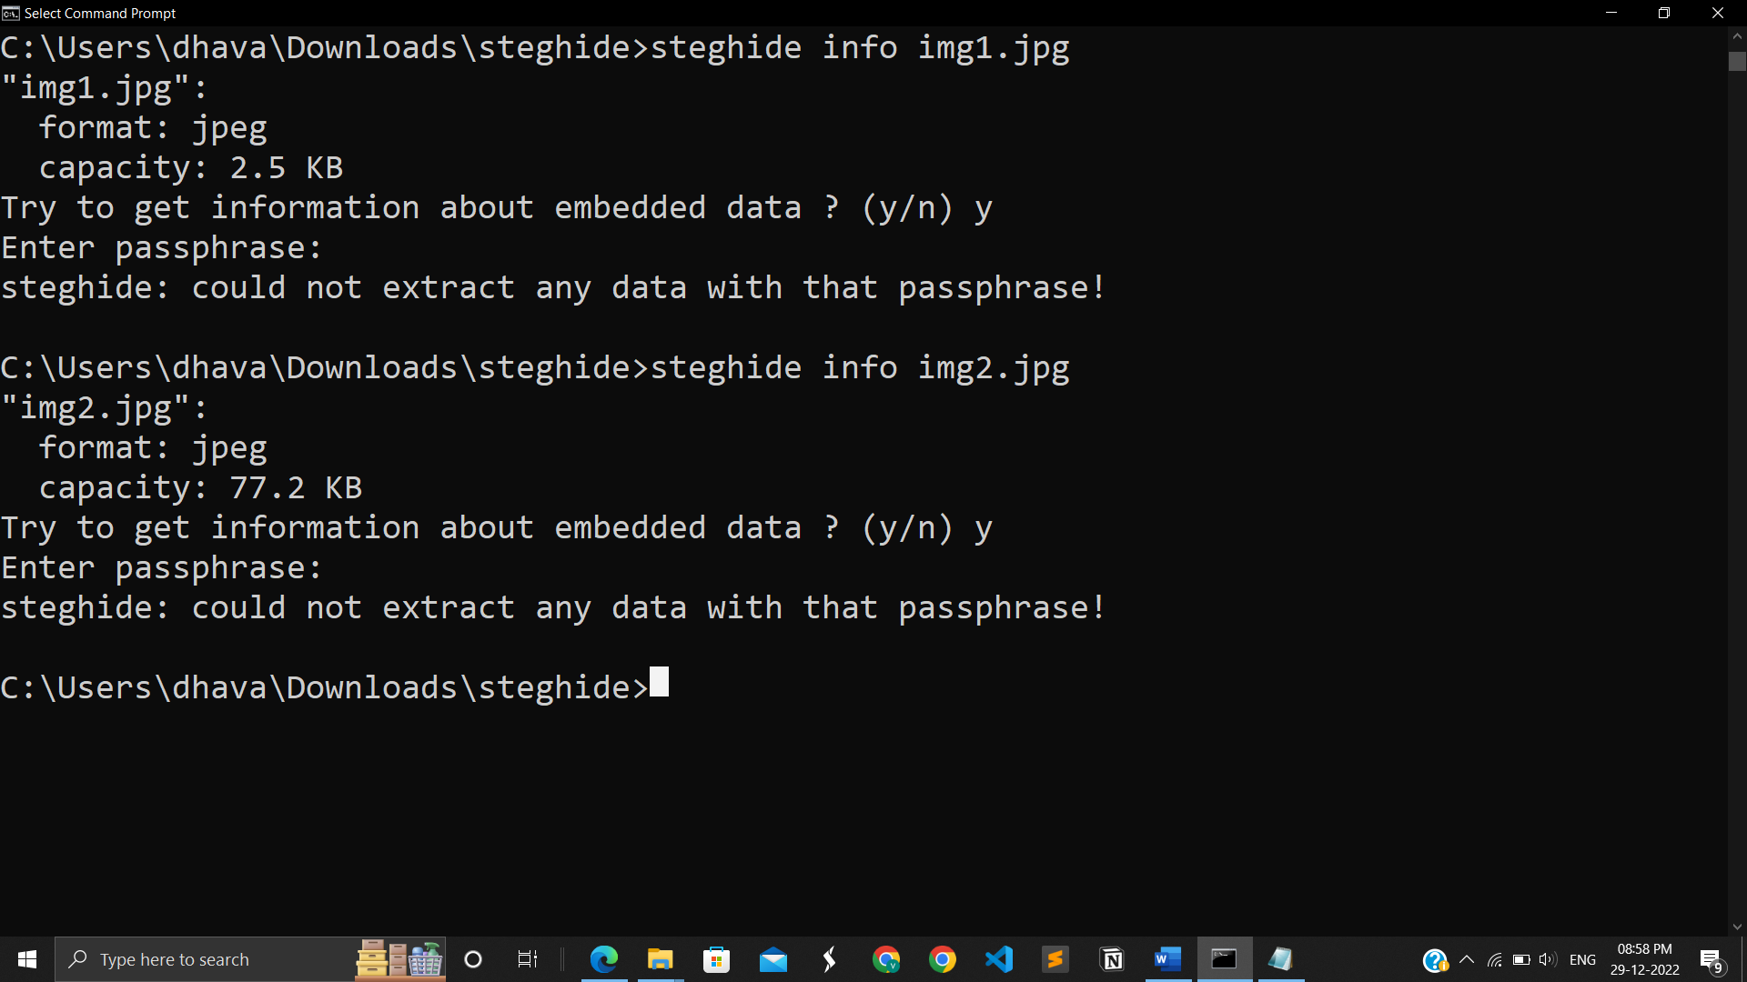

1.5 Both file data and having space to for hiding data

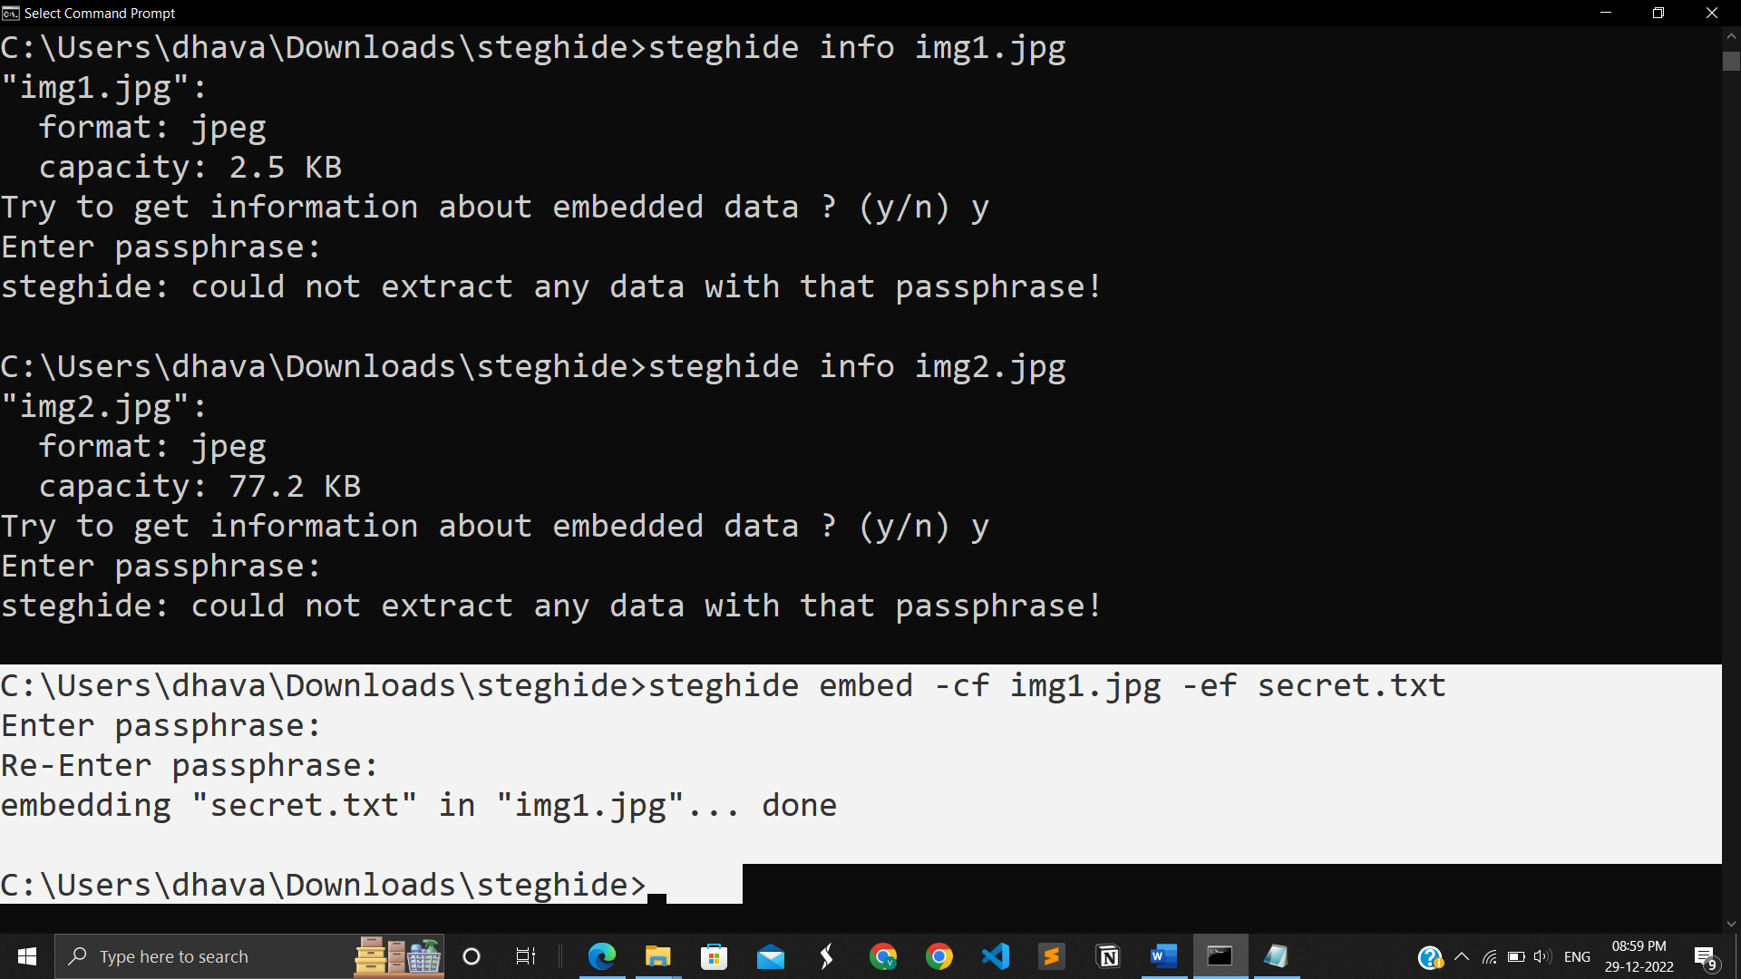

1.6 Secret.txt file is embedded in img1.jpg

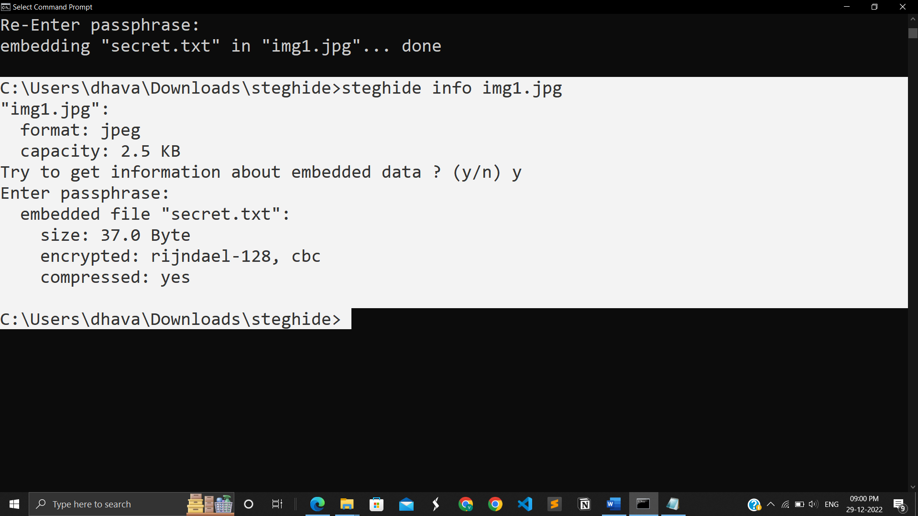

1.7 Details of img1 that I have embedded

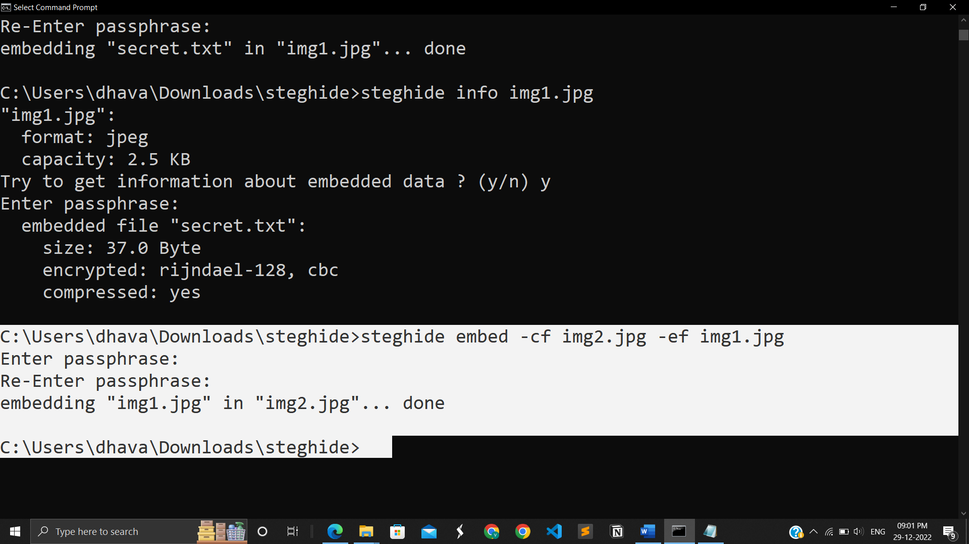

1.8 Img1 is embedded in img 2 Successfully

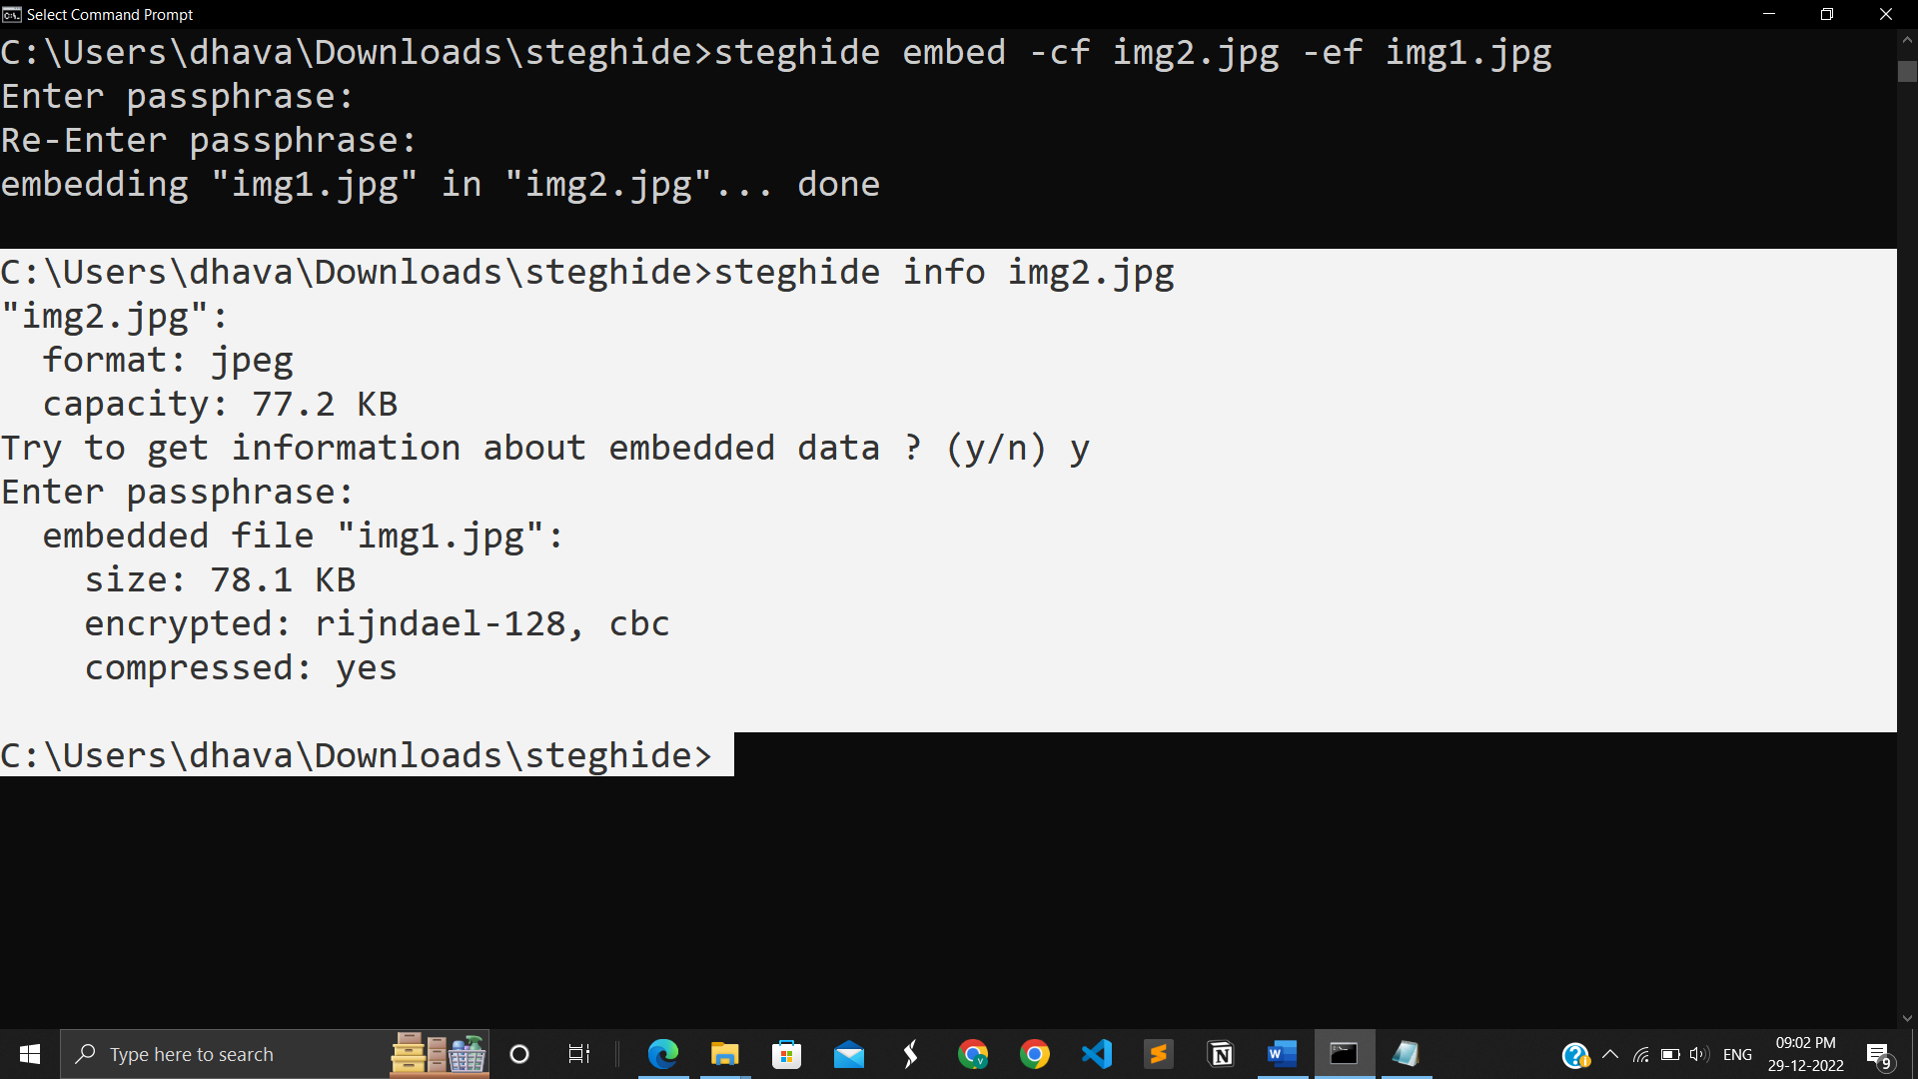1.9 info of img2 after embedding

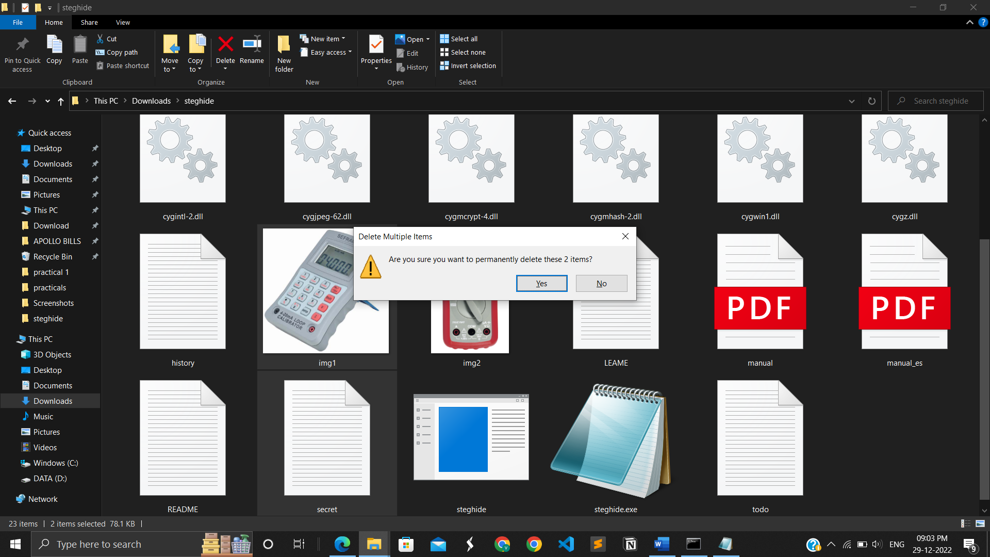

1.10 Deleting img1 and secret file

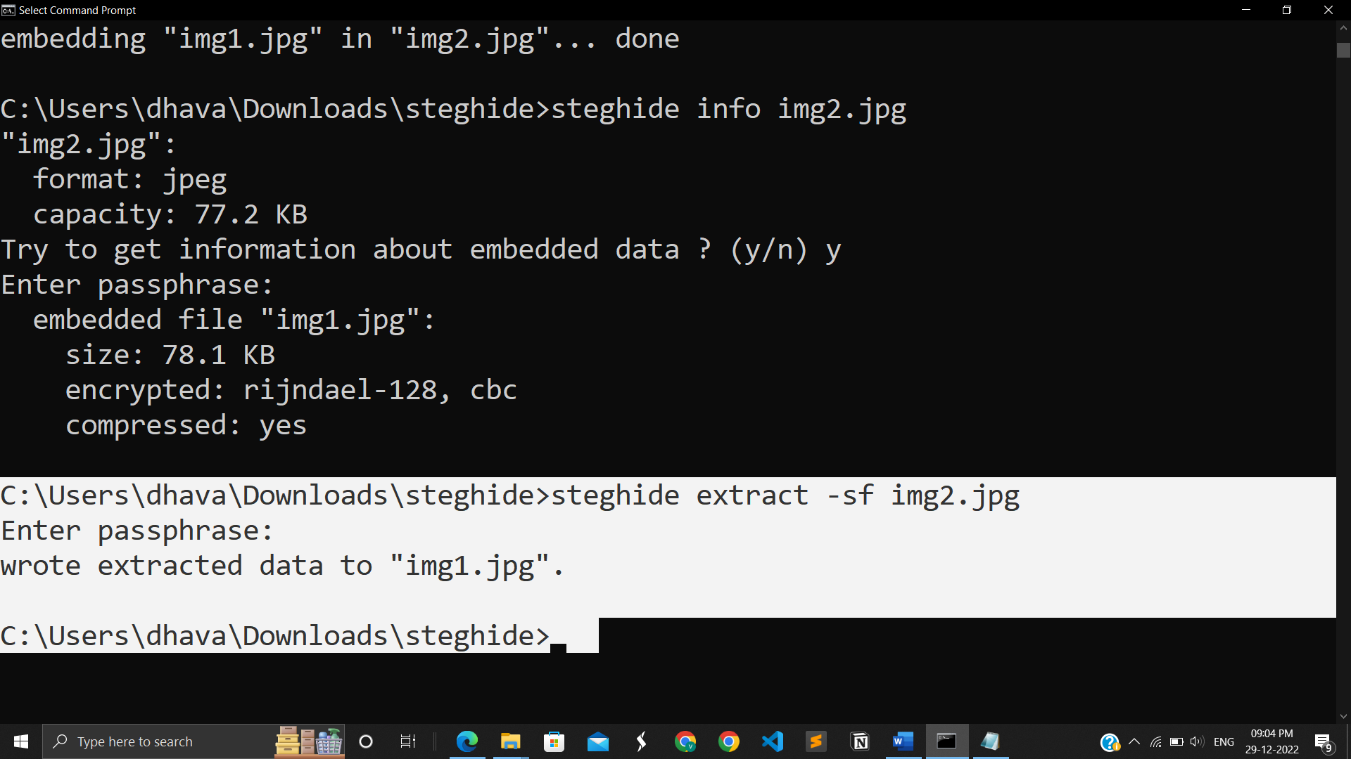

1.11 Successfully extracted img1.jpg from img2.jpg

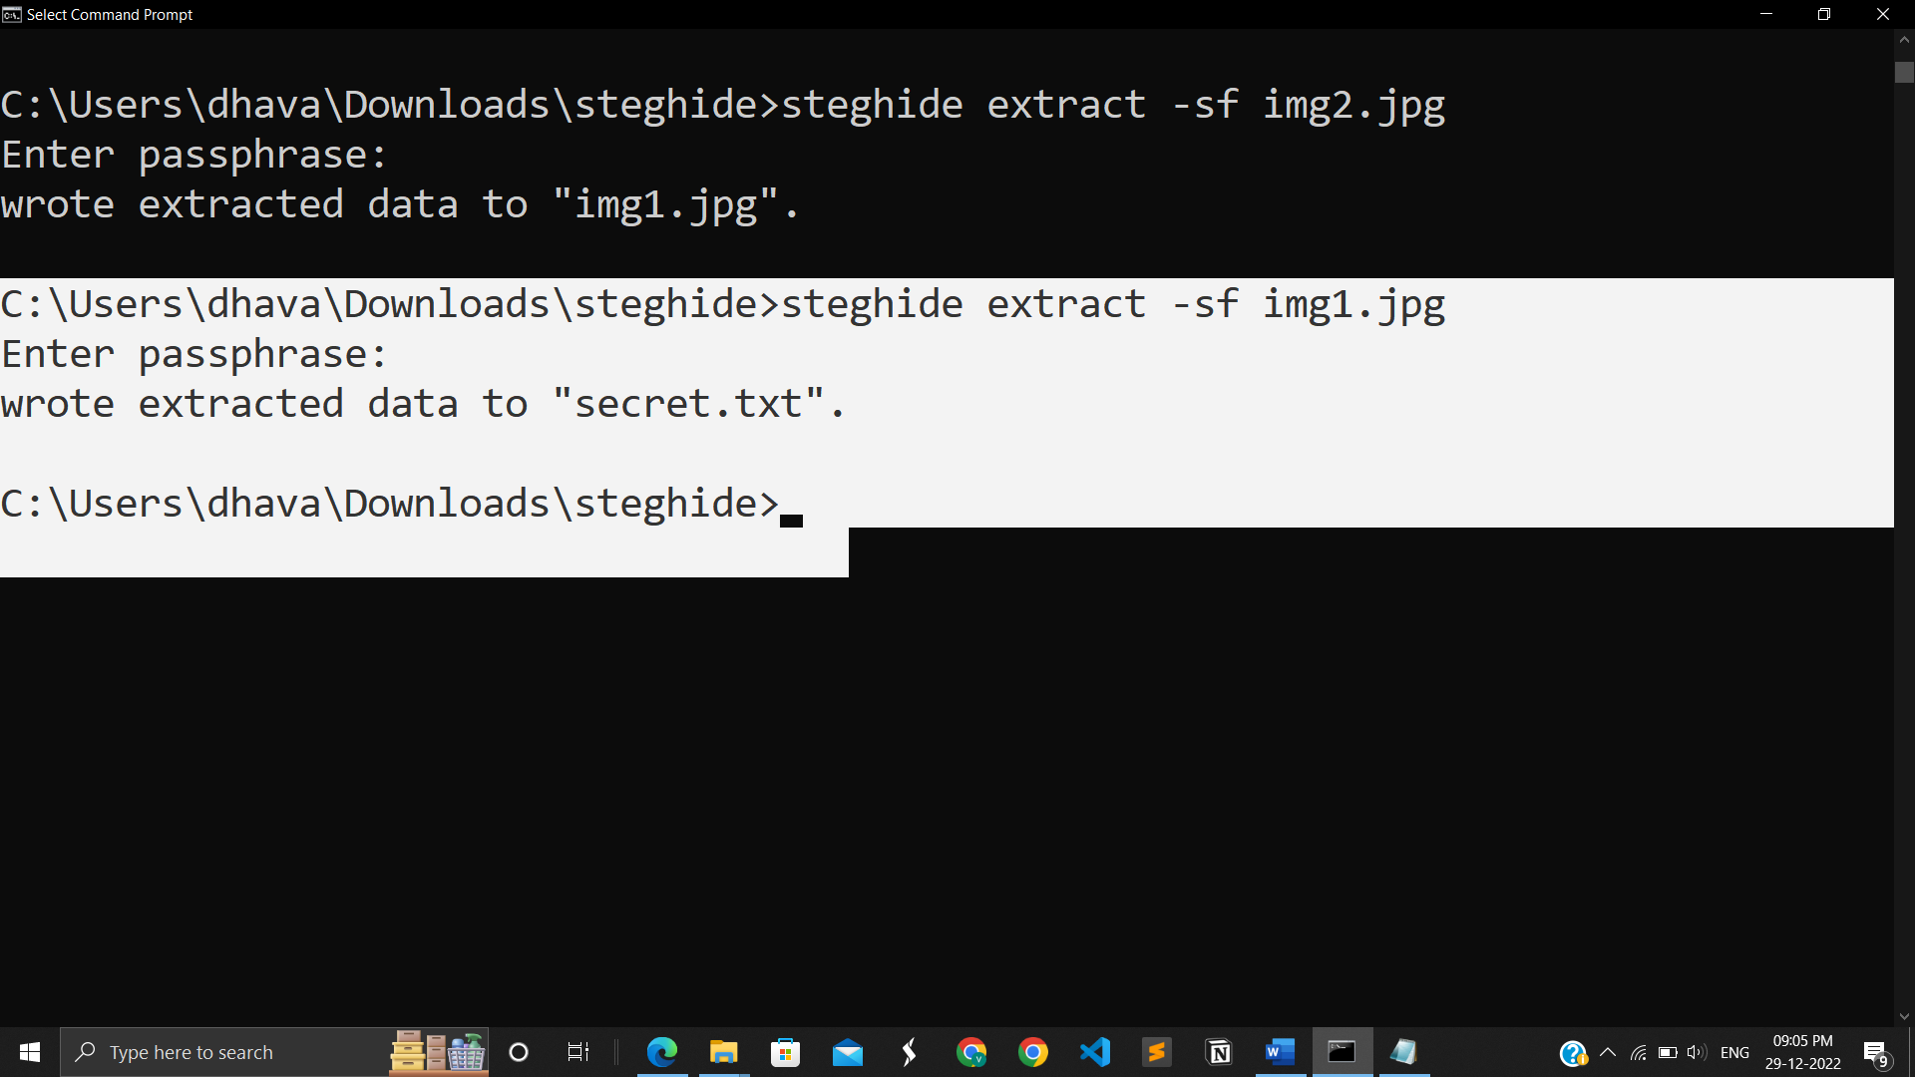

1.12 Successfully extracted secret.txt from img1.jpg

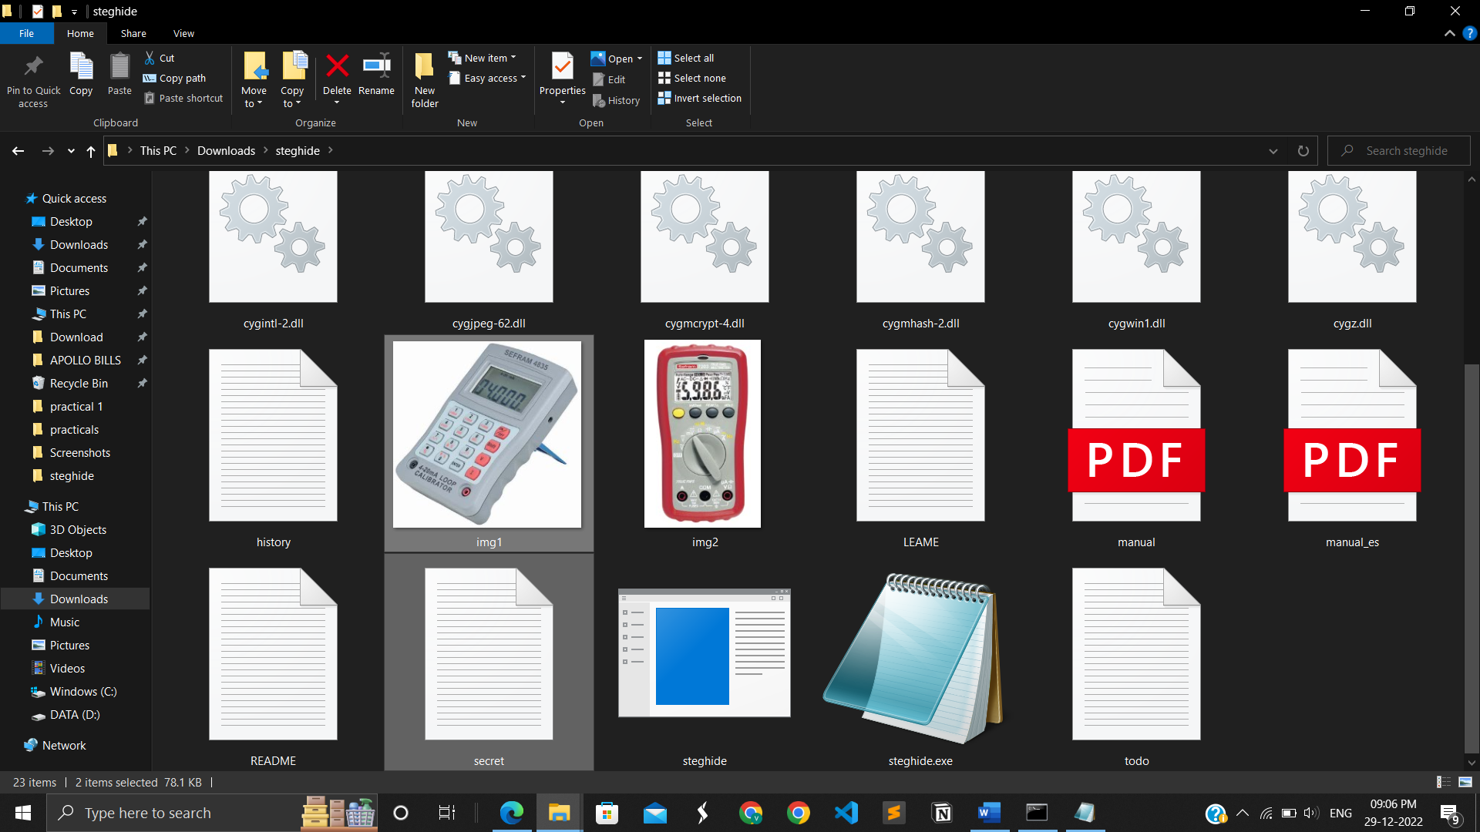

1.13 In folder .txt and img1 are also visible

**LATEST APPLICATION:**

* Protection of data alteration.
* Confidential communication and secret data storing.
* Access control system for digital content distribution.
* Digital watermarking.

**LEARNING OUTCOME:**

We learn to embed .txt file into images, images into images, audio into audio, txt into audio, and also we can compress and embed; we can also provide the algorithm we may utilise as a learning consequence from this practical.

**REFERENCES:**

Official website to download: <https://steghide.sourceforge.net/download.php>

Wikipedia for reources: <https://en.wikipedia.org/wiki/Steganography_tools>